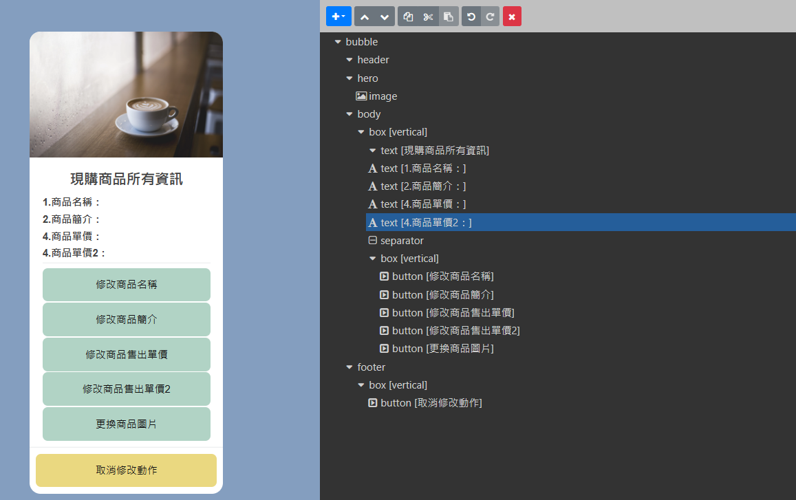

{

"type": "bubble",

"hero": {

"type": "image",

"url": "https://scdn.line-apps.com/n/channel_devcenter/img/fx/01_1_cafe.png",

"size": "full",

"aspectRatio": "20:13",

"aspectMode": "cover"

},

"body": {

"type": "box",

"layout": "vertical",

"contents": [

{

"type": "text",

"text": "現購商品所有資訊",

"weight": "bold",

"size": "xl",

"margin": "none",

"style": "normal",

"contents": [],

"align": "center"

},

{

"type": "text",

"text": "1.商品名稱：",

"margin": "md",

"weight": "bold"

},

{

"type": "text",

"text": "2.商品簡介：",

"margin": "sm",

"weight": "bold"

},

{

"type": "text",

"text": "4.商品單價：",

"weight": "bold",

"margin": "sm"

},

{

"type": "text",

"text": "4.商品單價2：",

"margin": "sm",

"weight": "bold"

},

{

"type": "separator",

"margin": "sm"

},

{

"type": "box",

"layout": "vertical",

"margin": "md",

"contents": [

{

"type": "button",

"action": {

"type": "message",

"label": "修改商品名稱",

"text": "修改商品名稱"

},

"color": "#B1D3C5",

"style": "secondary"

},

{

"type": "button",

"action": {

"type": "message",

"label": "修改商品簡介",

"text": "修改商品簡介"

},

"style": "secondary",

"color": "#B1D3C5"

},

{

"type": "button",

"action": {

"type": "message",

"label": "修改商品售出單價",

"text": "修改商品售出單價"

},

"style": "secondary",

"color": "#B1D3C5"

},

{

"type": "button",

"action": {

"type": "message",

"label": "修改商品售出單價2",

"text": "修改商品售出單價2"

},

"style": "secondary",

"color": "#B1D3C5"

},

{

"type": "button",

"action": {

"type": "message",

"label": "更換商品圖片",

"text": "更換商品圖片"

},

"style": "secondary",

"color": "#B1D3C5"

}

],

"spacing": "xs"

}

]

},

"footer": {

"type": "box",

"layout": "vertical",

"contents": [

{

"type": "button",

"action": {

"type": "message",

"label": "取消修改動作",

"text": "取消修改動作"

},

"style": "secondary",

"color": "#EAD880"

}

],

"spacing": "xs",

"margin": "md"

},

"styles": {

"footer": {

"separator": true

}

}

}